Set-up

Jenkins is installed on a build server. In my set-up the build server is the same as the release server, but this can be configured differently.

*Download and install* Jenkins for your platform here: https://jenkins-ci.org/

After installation Jenkins is available on its default port: <http://localhost:8080/>

Configure Jenkins

Jenkins has plugins for understanding Git repositories, MSBuild files and various other technologies. In the current set-up we only need to extend Jenkins with those two plugins.

Install the Git Plugin for Jenkins:

1. Open Jenkins, <http://localhost:8080/>
2. Navigate to “Manage Jenkins”
3. Navigate to “Manage Plugins”*Direct link:*[*http://localhost:8080/pluginManager*](http://localhost:8080/pluginManager)
4. Use the “filter” box to search for “Git plugin” and install the plugin.

Install the MSBuild Plugin for Jenkins:

1. Open Jenkins, <http://localhost:8080/>
2. Navigate to “Manage Jenkins”
3. Navigate to “Manage Plugins”*Direct link:*[*http://localhost:8080/pluginManager*](http://localhost:8080/pluginManager)
4. Use the “filter” box to search for “MSBUILD plugin” and install the plugin.

Jenkins now understands MSBuild files and Git source control, but we still need to configure the MSBuild Plugin with a path to the msbuild.exe we would like to use.

MSBuild configuration

When the MSBuild plugin was installed it added its own configuration options to the Jenkins global configuration page.

1. Navigate to <http://localhost:8080/>
2. Click “Manage Jenkins”
3. Click “Configure System”
4. Scroll down the list until you find “MSBuild”
5. Click the “MSBuild installations…” button
6. Click “Add MSBuild”
7. Give the new MSBuild configuration a name like “MSBuild-default”.
8. In the path field, insert the fully qualified path to msbuild.exeOn my server the path is: C:Program Files (x86)MSBuild14.0Binmsbuild.exe, but this can be different on your system.

Read below for more information about MSBuild and how to install it.

1. Click save.

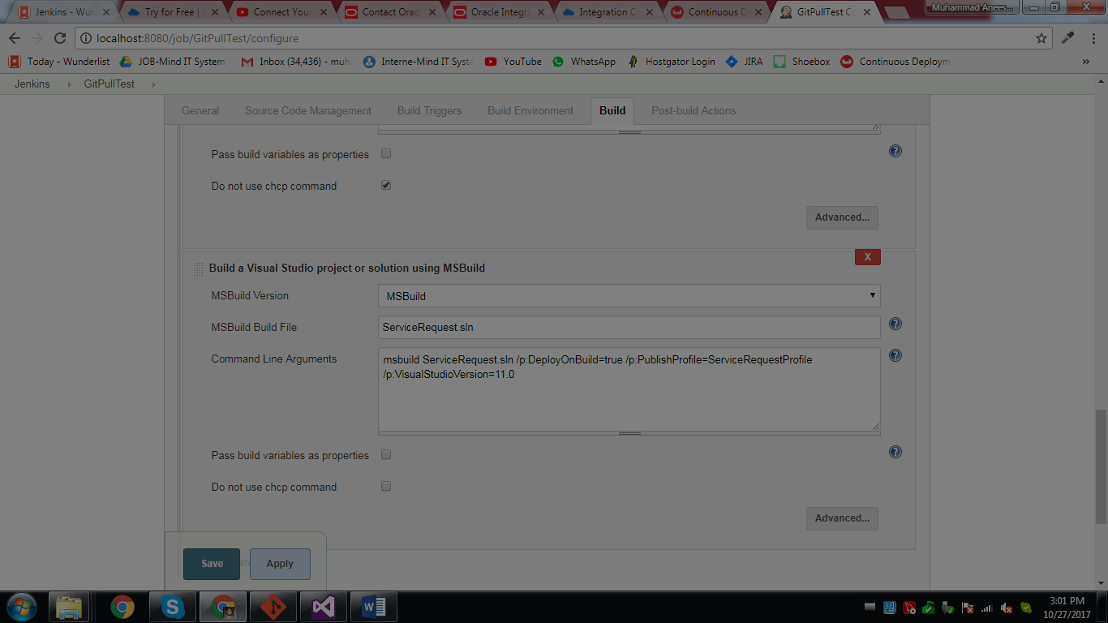

**Global tool config for gitexe and msbuild exe and for other global exe files path set**

**Set environment variable for msbuild if it is not working in msbuild command prompt. To check or commands are running in cmd properly , (you can skip this step)**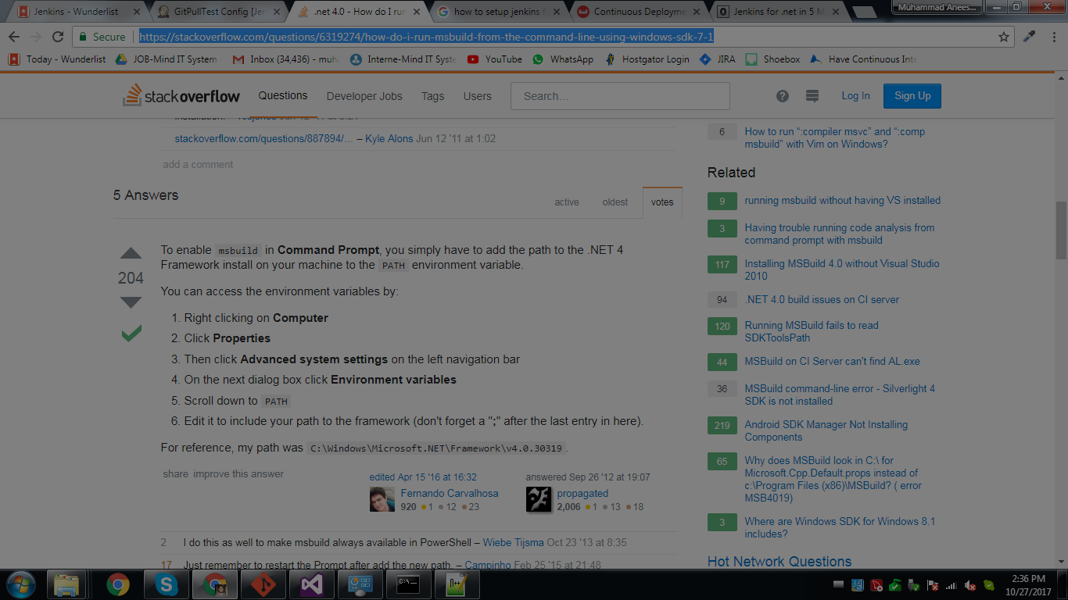I need to open msbuild command promt to check it.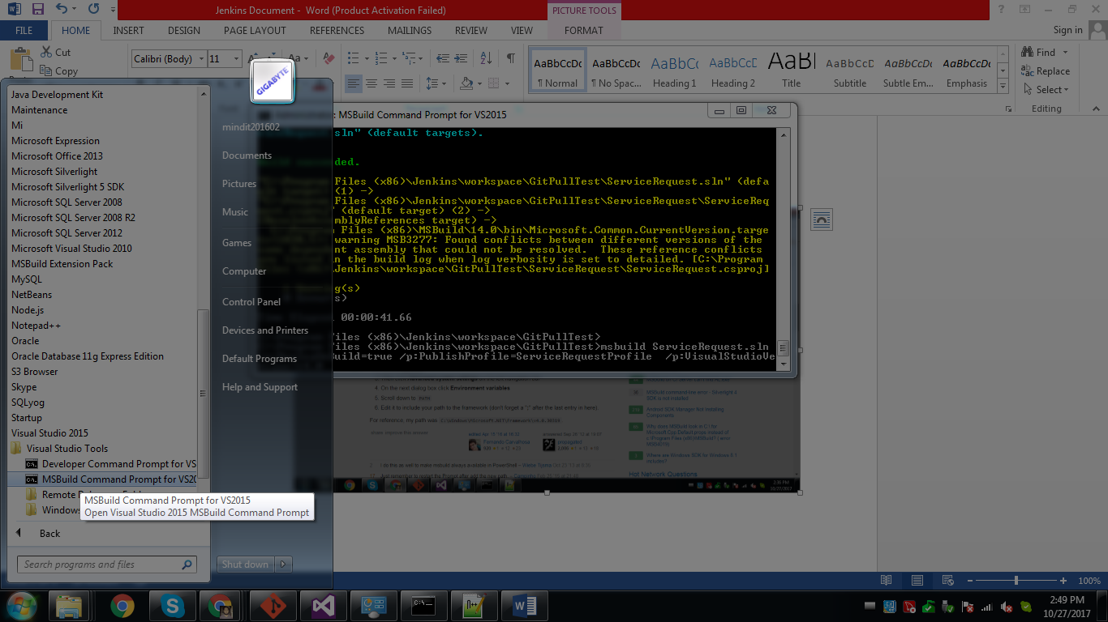

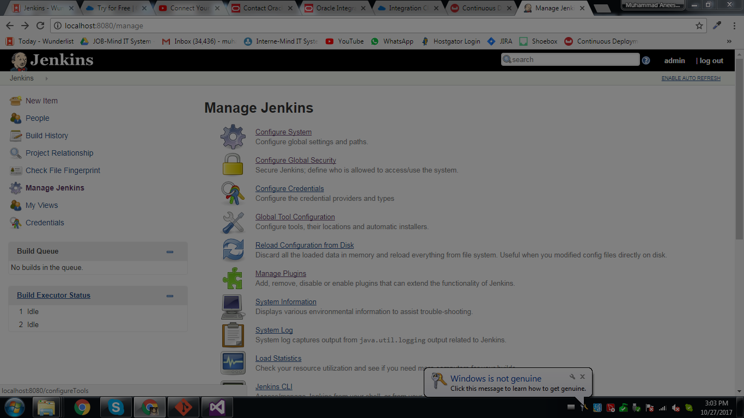

**Manage plugins click and installed required plugin**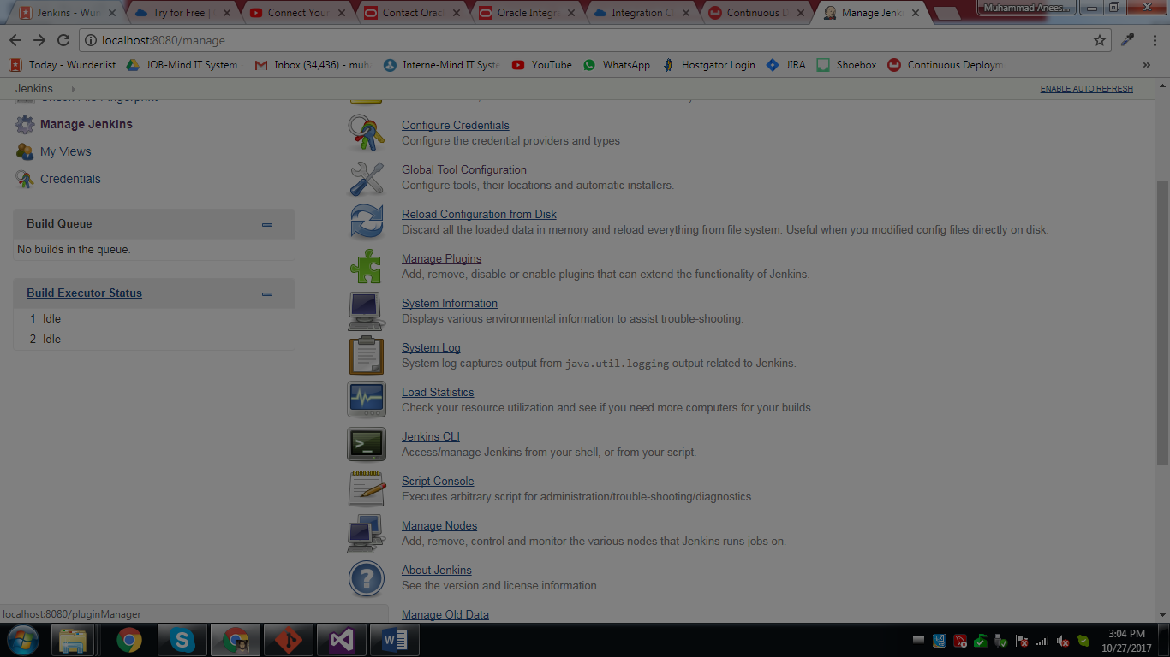

**Install without restart**

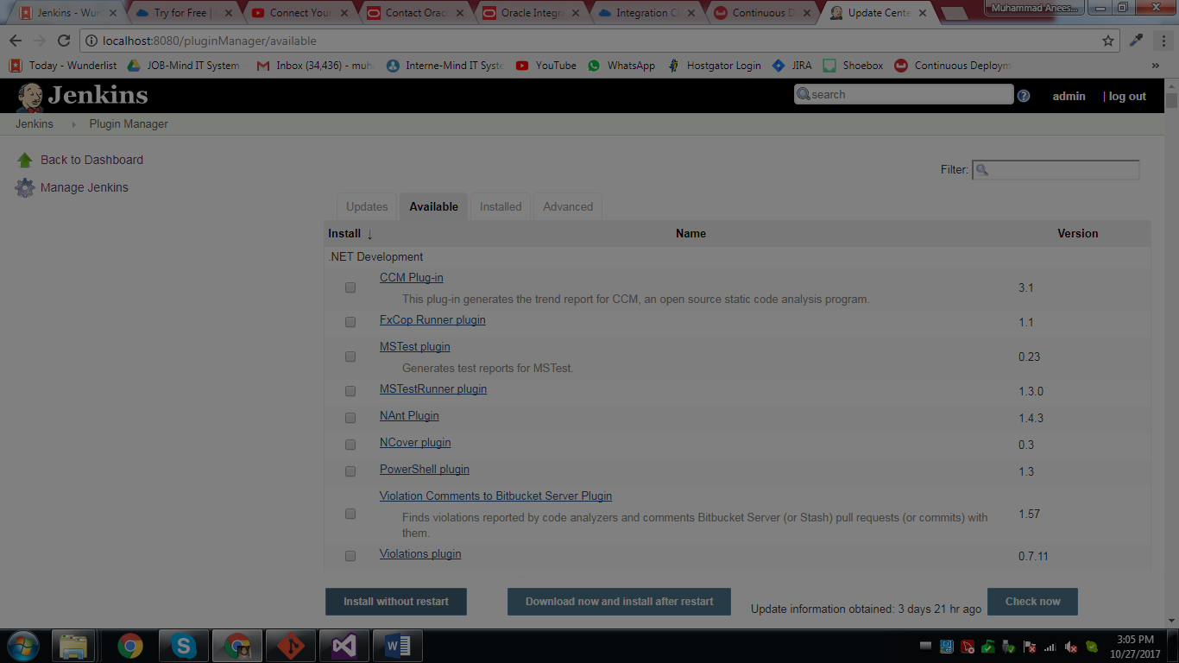

**Msbuild framework environment set variable** 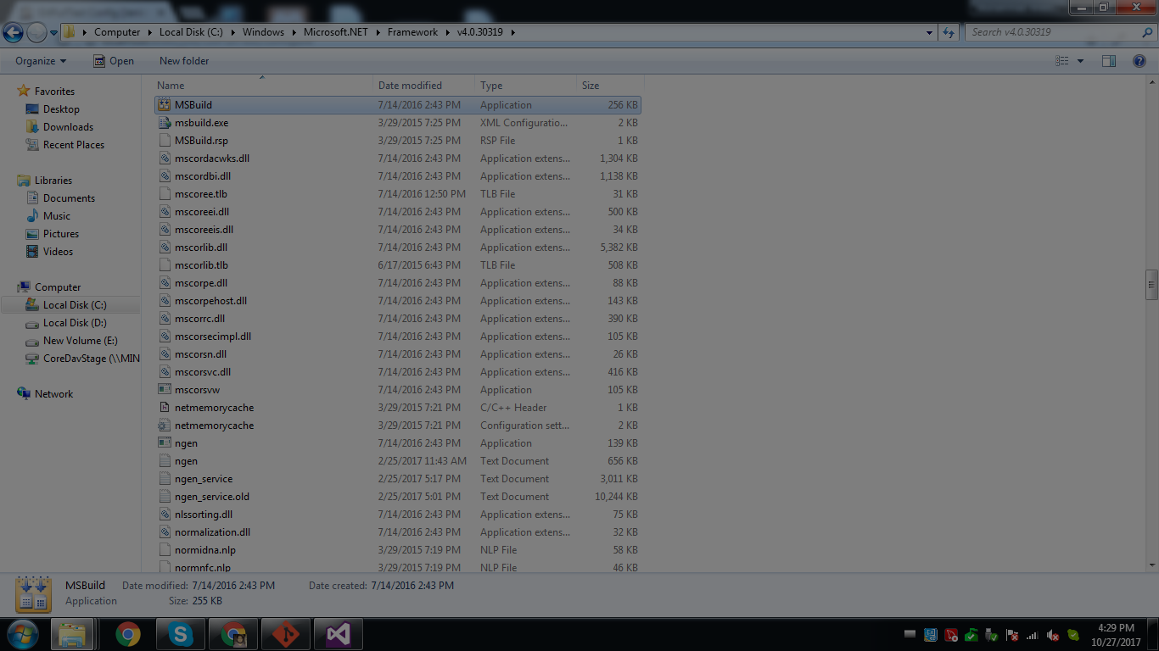

**Initiate new free style project for any build**

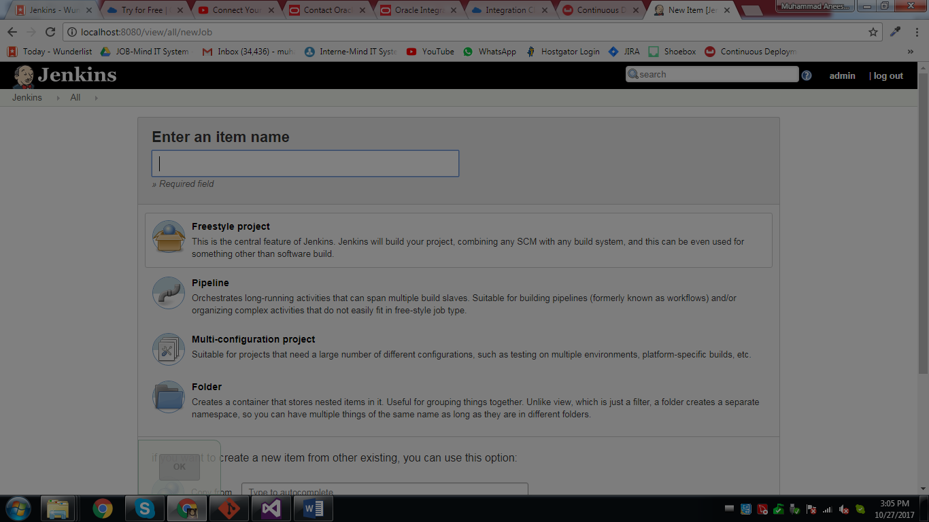

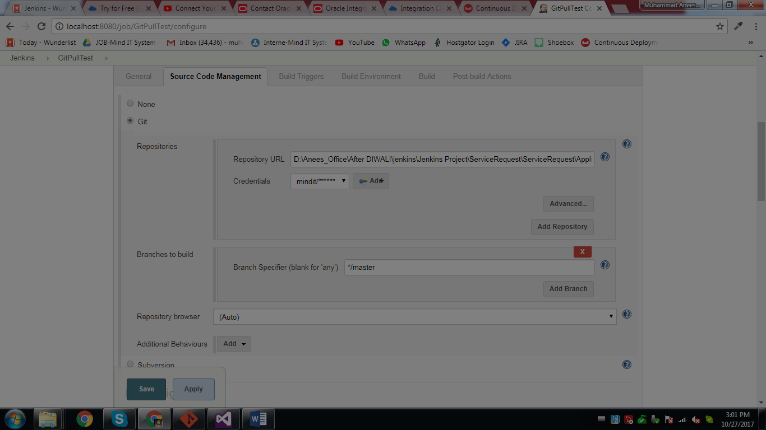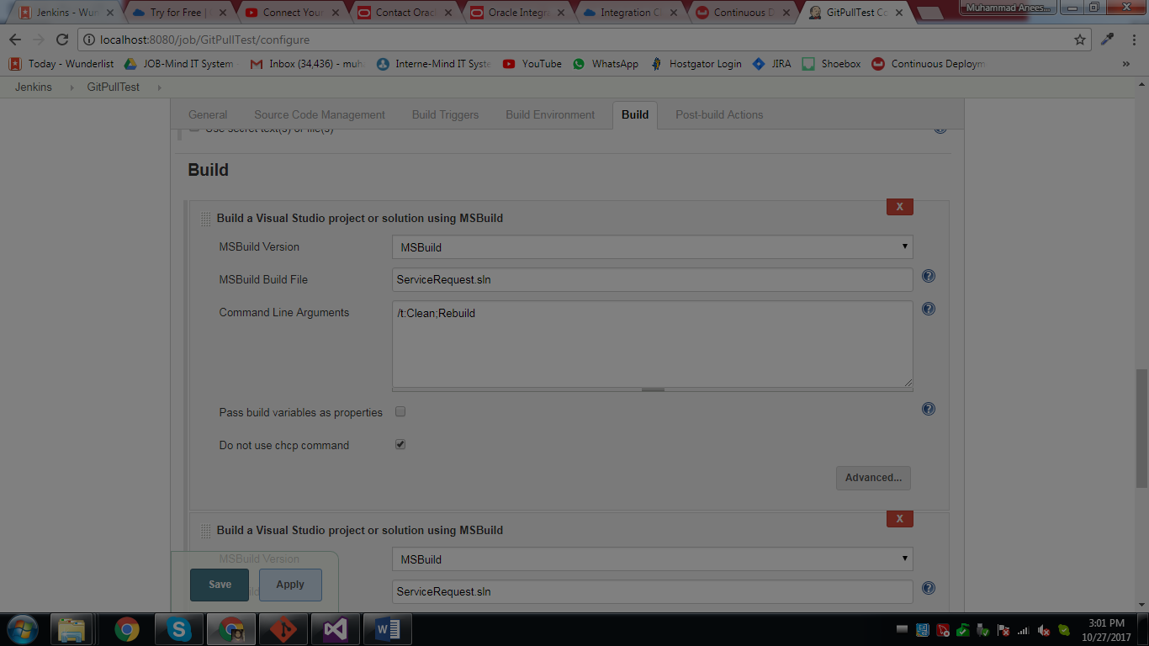

**\*\* if you transfer Jenkins job to another pc then just add jobs and workspace to corresponding directory and then restart the system.**

**Take care of changing environment variables in** [Configure System](http://localhost:8080/configure), [Configure Global Security](http://localhost:8080/configureSecurity), [Global Tool Configuration](http://localhost:8080/configureTools), as per requirement in various of job steps.

[**https://wiki.jenkins.io/display/JENKINS/Administering+Jenkins**](https://wiki.jenkins.io/display/JENKINS/Administering+Jenkins)

**cloning git from remote machine s:-**

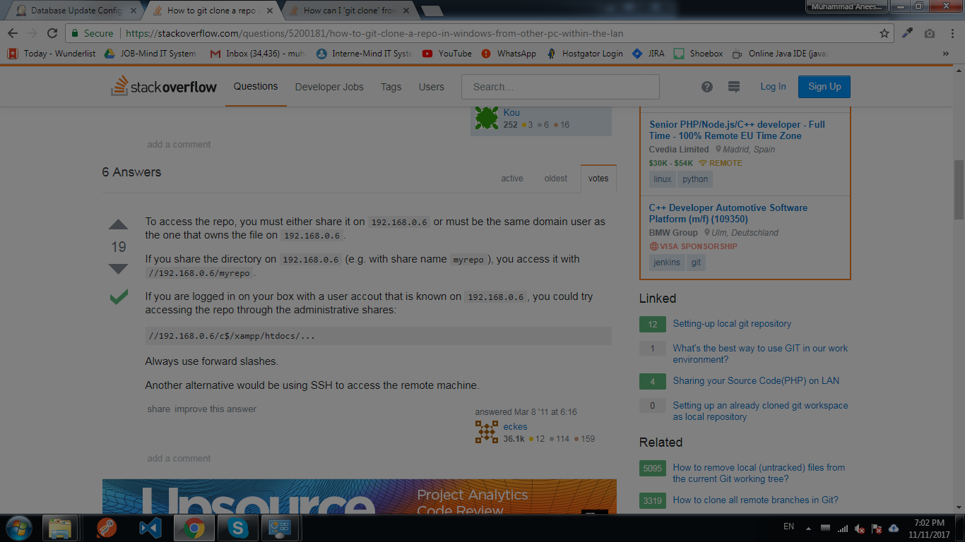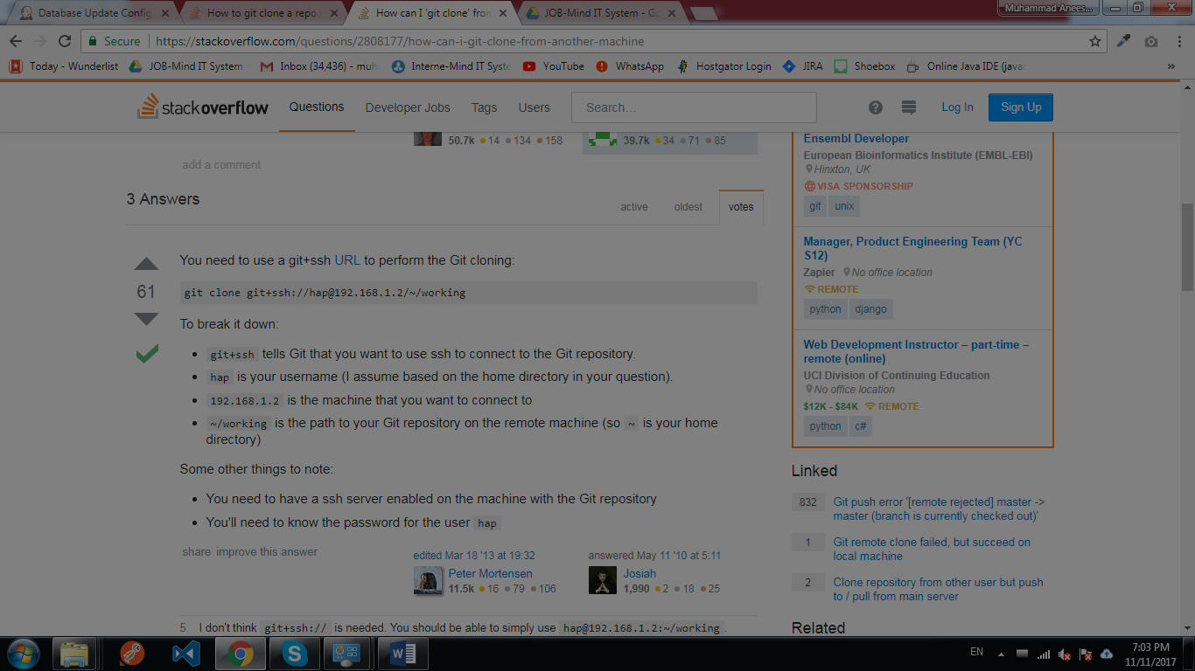

**From same machines:-** 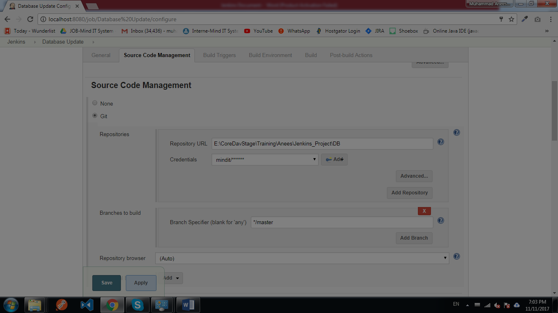

**For installing ftp server and site on remote check following link:-** [**https://www.youtube.com/watch?v=nWpZkhXnhds**](https://www.youtube.com/watch?v=nWpZkhXnhds)

**For installing ssh server and site on remote check following link:-** <https://www.techrepublic.com/blog/tr-dojo/set-up-a-free-ssh-server-on-windows-7-with-freesshd/>

For accessing ssh from local machine to remote server in order to check if it is working correctly or not before testing in Jenkins then use PUTTY.

**For**

**'7z' is not recognized as an internal or external command,**

**operable program or batch file. Error**

**then after setting the path in remote server mycomputer environment variable , restart the server.**

* + **In ftp folder permission are important to transfer , remove read only like below** 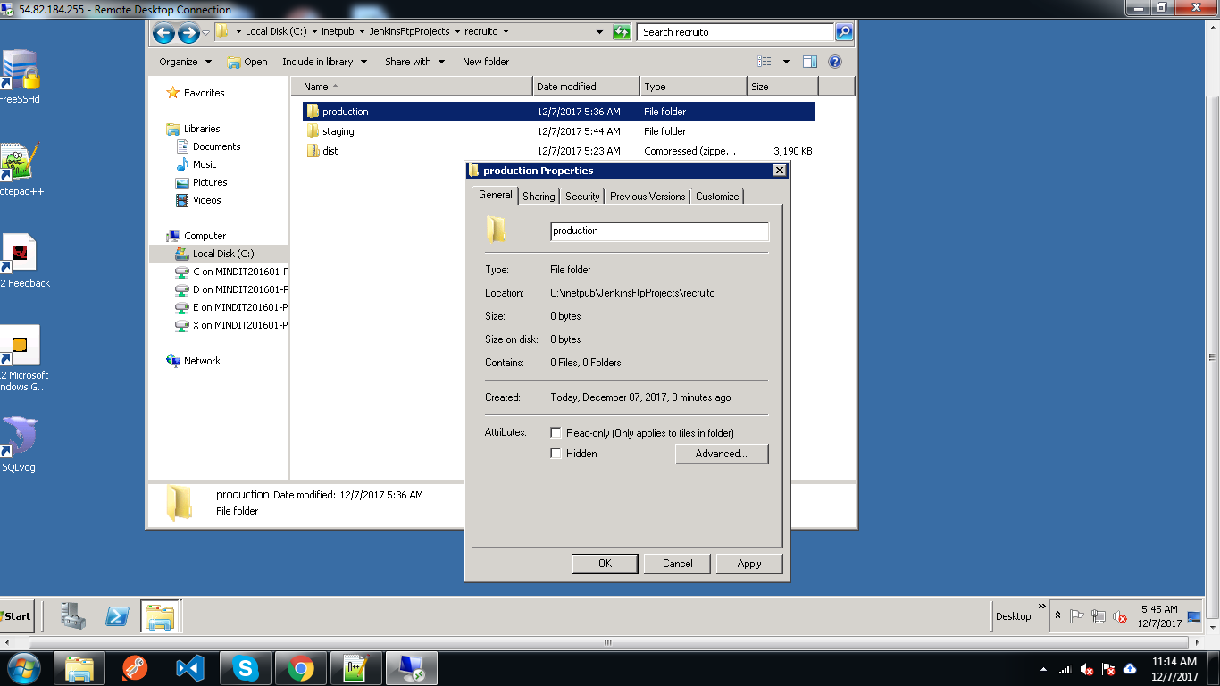

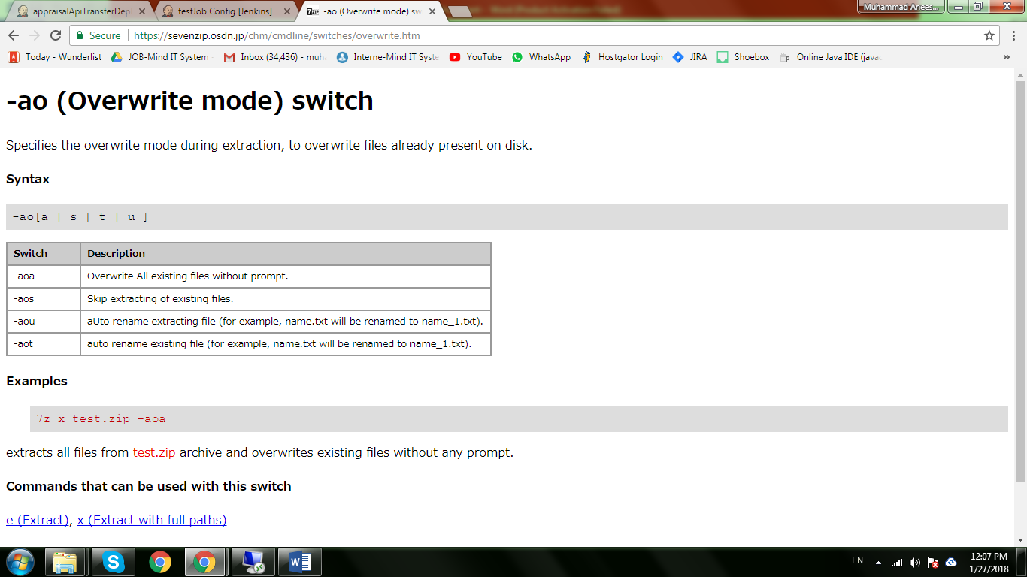

**https://support.microsoft.com/sq-al/help/240268/copy--xcopy--and-move-overwrite-functionality-changes-in-windows**